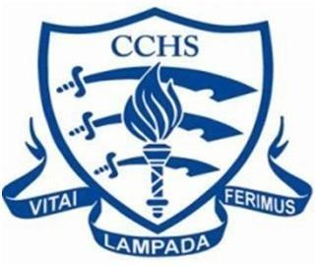

Chelmsford County High School for Girls
Year 13 A Level Results – Summer 2023
A*- B – 85.23%

Year 13 Students on Roll
SUBJECT | ENTRIES | A* | A | B | C | D | E
Art, Craft & Design | 11 | 8 | 3 | 0 | 0 | 0 | 0
Biology | 67 | 17 | 23 | 19 | 6 | 1 | 1
Chemistry | 52 | 4 | 20 | 13 | 10 | 5 | 0
Computer Science | 10 | 0 | 7 | 2 | 1 | 0 | 0
Economics | 35 | 8 | 13 | 6 | 6 | 1 | 1
English Literature | 38 | 6 | 14 | 14 | 3 | 1 | 0
French | 19 | 5 | 9 | 4 | 1 | 0 | 0
Geography | 17 | 6 | 5 | 3 | 2 | 1 | 0
German | 3 | 1 | 1 | 1 | 0 | 0 | 0
History | 28 | 1 | 8 | 11 | 5 | 1 | 2
Latin | 2 | 0 | 1 | 1 | 0 | 0 | 0
Mathematics | 63 | 19 | 27 | 10 | 5 | 2 | 0
Further Mathematics | 10 | 4 | 4 | 2 | 0 | 0 | 0
Music | 6 | 0 | 1 | 2 | 3 | 0 | 0
Physics | 21 | 2 | 6 | 6 | 5 | 1 | 1
Politics | 21 | 1 | 13 | 5 | 2 | 0 | 0
Psychology | 60 | 18 | 21 | 13 | 7 | 1 | 0
Religious Studies | 14 | 3 | 7 | 4 | 0 | 0 | 0
Spanish | 4 | 0 | 0 | 3 | 1 | 0 | 0
Theatre St | 15 | 1 | 4 | 10 | 0 | 0 | 0
TOTALS | 496 | 104 | 187 | 131 | 57 | 13 | 5
EPQ (1/2 A level) | 18.5 | 4.5 | 9.5 | 4.5 | 0 | 0 | 0
TOTALS | 514.5 | 108.5 | 196.5 | 135.5 | 57 | 13 | 5
% of grade (exc EPQ) |  | 20.97% | 37.70% | 26.41% | 11.49% | 6.62% | 1.01%
% of grade (inc EPQ) |  | 21.09% | 38.19% | 26.33% | 11.08% | 2.53% | 0.97%
Some of the above figures may increase following remarks.

